Notes on TCM SID 97-3E
Normally Aspirated Engines
Dan MacDonald
September 2010
Version 2

I have discovered that many mechanics are not sufficiently knowledgeable about TCM fuel injection to properly setup or maintain the system. This document summarizes what has been learned thus far, in an effort to help others in their quest for a properly running TCM normally-aspirated fuel-injected engine.

Note: Enlist the help of a properly certified mechanic and be sure to follow TCM and airframe manufacturer manuals and publications before performing any fuel injection work. Use the following information, or not, at your own risk.

Tools

First, the SID specifies the tools required to adjust your fuel injection. It recommends the Model 20 ATM-C Porta Test Unit, which unfortunately costs thousands of dollars. However, it also lists alternate tools, including three analog pressure gauges in various ranges. I have discovered that most mechanics do not have the test equipment, and those who do may have old gauges that have not been calibrated in this century. Examining one mechanic’s setup revealed that one gauge always read zero, another had leaked the glycerin fluid and appeared to be “stuck”, one did not show zero at rest, and the final one was far out of calibration. He had been using them to setup airplanes for years, probably without much success.

The solution for you, the aircraft owner, is to build up your own set of brand new test gauges. With careful handling and storage they should remain accurate for several years. Then you can have them recalibrated, or throw them away and purchase new ones. In addition, you will also need hoses and fittings to connect the gauges to your engine. The SID only identifies one of the fittings needed, PN MS51523-B4 Swivel Tee. Sources, part numbers, and prices (current as of this writing) for all needed parts are listed below. 4” diameter gauges have been selected because they can be read more precisely than the 2-1/2” versions.

Note that TCM recommends a 0-60 psi gauge to set the unmetered pressure. However, this gauge is primarily used to set the idle unmetered pressure which varies from 4 – 10 psi, depending on the engine. It is impossible to properly set such a low pressure accurately using a high pressure gauge. Instead, use a 0-15 psi gauge specifically for that portion of the procedure. The SID’s 0-60 psi gauge can also be used to verify the full power unmetered pressure, but is not required or included below. A second gauge of 0-30 psi will be needed to measure the full-power metered fuel pressure.

Gauges

1 Wika 0-15 psi 4” pressure gauge, Grainger pn 4VE35 $35.35
1 Wika 0-30 psi 4” pressure gauge, Grainger pn 4VE41 $35.35
1 20’ Twist-Tite fuel hose -4, Summit Racing pn SUM-220782 $42.95
2 Twist-Tite ¼” -4 end straight, Summit Racing pn SUM-220700 $3.95 ea
2 Twist-Tite ¼” -4 ¼” adapter, Summit Racing pn SUM-220750 $2.88 ea
2 Earls ¼” NPT coupling, Summit Racing pn EAR-991002ERL $3.95 ea
1 or 2 Swivel Tees, Genuine Aircraft Hardware pn MS51523B4Z $11.95 ea

Optional, and not pictured in this article: In place of one coupling above, purchase a valve to allow you to turn off the pressure to your 0-15 psi gauge during engine start or high speed runs. This will protect the gauge from accidental overpressure damage. You might try the Brass ball valve, 1/4” NPT female on both ends, part number 110260073 from B&F Marine, $14.

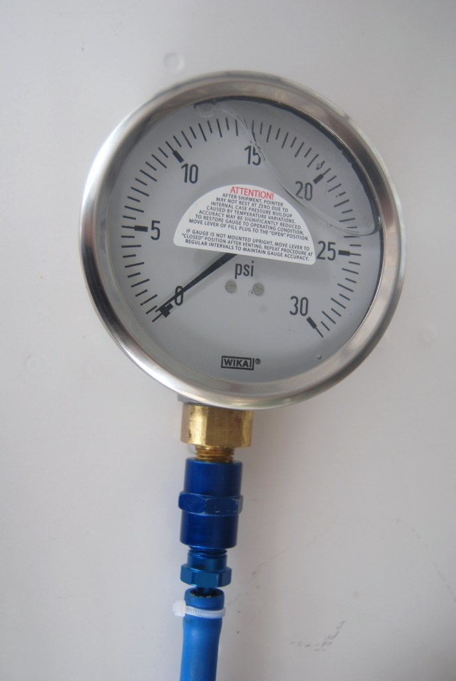

Photo 1: 0-30 psi Wika 4” gauge with coupling, NPT adapter, and hose attached. The white zip-tie used here should be replaced with a small hose clamp.

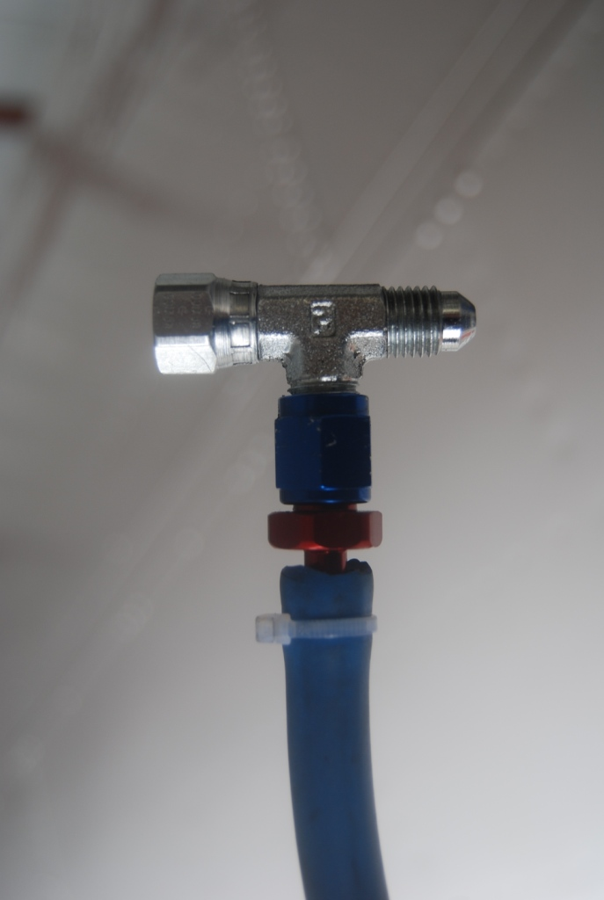

Photo 2: AN-4 Swivel Tee (silver), with hose and AN-4 end (red and blue) attached. Again, the white zip-tie shown here should be replaced with a small hose clamp.

Tachometer

The tachometer in the airplane is not accurate enough for this procedure. The rpm must be set precisely for the gauge measurements to have value. You will need an electronic/optical/digital tachometer. These compute rpm by sensing light pulses from a rotating prop, and work best when the sun is towards the front of the plane. They do not work with florescent light due to the 60 cycle flicker which will display as 3600 rpm, although this can be a good calibration test for the tach. The tachometer can be set for either a 2 or 3 bladed prop. One example is the Hobbico Digital Mini Tach which can be purchased from a local RC airplane hobby store for ~$28, see Photo 3 below. You should be able to find something similar either locally or online.

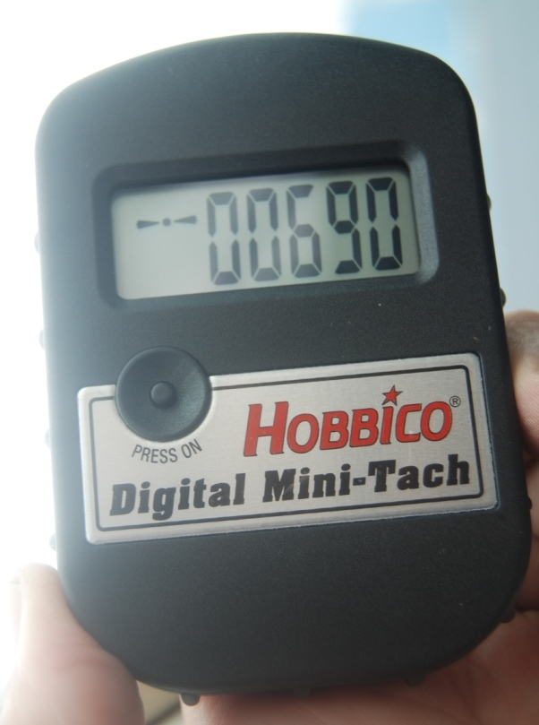

Photo 3: Hobbico Electronic Tach in two-blade prop mode showing an idle speed of 690 rpm

Fuel Flow Computer

Note that the full power metered fuel flow can be set by either a pressure gauge or a digital fuel flow computer. If you have an accurate fuel flow computer installed in your airplane, you should use it as primary and verify that the pressure is reasonable using a pressure gauge. Be certain that the fuel flow computer is accurate. One method is to compare the computed fuel consumption on long trips to the amount of fuel purchased at each stop. It should be consistently within a few tenths of a gallon. If the error is large, see the instructions for calibrating your fuel flow computer. It usually involves adjusting the K-factor (pulses per gallon).

If you do not have a fuel flow computer in your airplane, you can set the full power fuel flow using only the 0-30 psi Wika pressure gauge.

Procedure

Follow the SID instructions carefully. Note the following additional hints:

- Route the hoses out the oil filler door or cowling and in through the pilot window, per photo 4. Some aircraft have firewall fittings pre-installed allowing you to run hoses from the various measurement points to the firewall, then from the back of the firewall to the gauges.

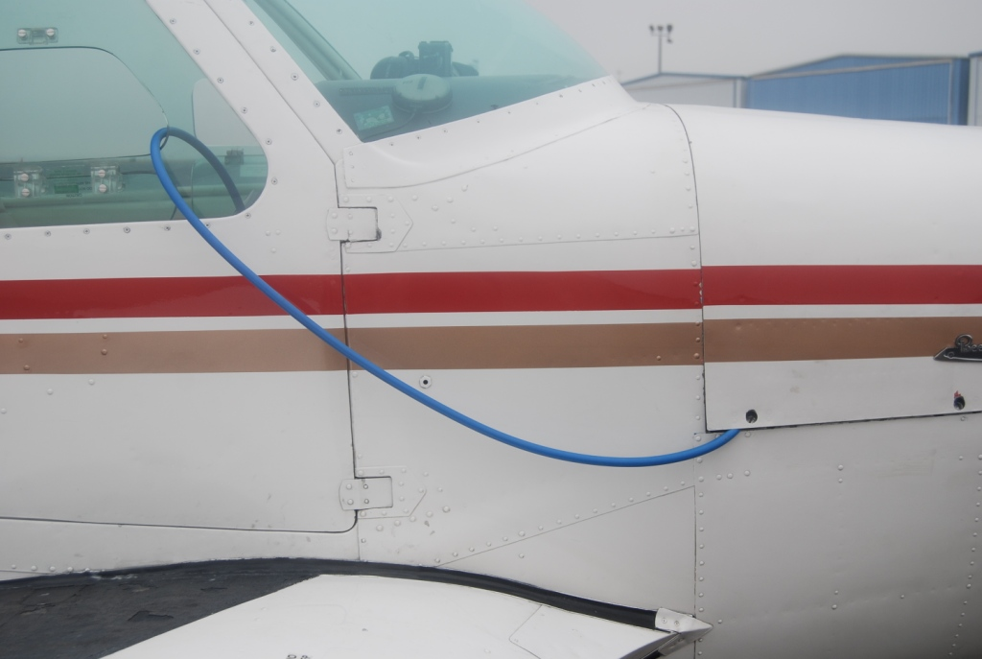

Photo 4: One possible hose routing. Be careful to not
compress or cut the hose where it exits the cowling

- Before using your gauges:

  - Ensure that they read zero at rest
  - Verify the glycerin fluid filling has not leaked out
  - Bleed air out of the line by loosening the fitting near the gauge (over a bucket, be careful of fire!)
  - Keep the gauge at the same height as the point being measured. If it is above, it will read too low. If it is below, it will read too high.
  - Equalize the pressure inside the gauge case with ambient pressure by flipping the little yellow valve open, then closed. See Photo 5 below.

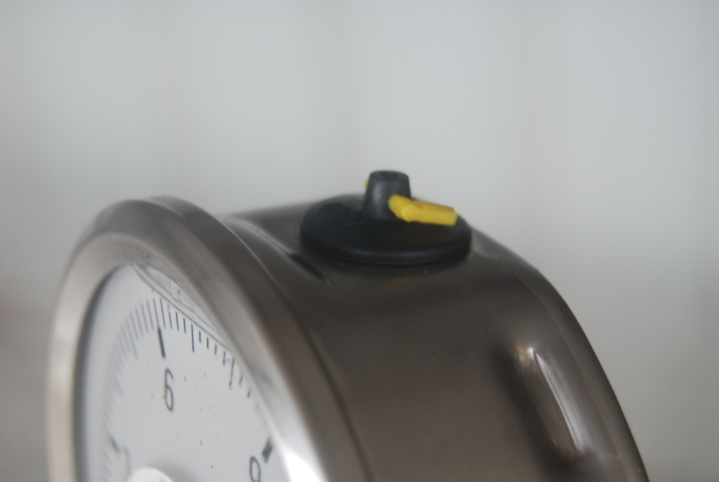

Photo 5: Small yellow lever on gauge opens a valve to equalize internal case pressure with ambient pressure. Open and reclose before each use.

Idle Unmetered Fuel Pressure, Idle Mixture, and Idle Speed

- These calibrations also index the throttle butterfly with the fuel control valve, affecting the fuel-air mixture at all throttle and mixture settings. It is extremely import that this be done properly.

- You will use a swivel tee to tap into the fuel line between the fuel pump and the fuel controller to measure unmetered fuel pressure.

- Use the electronic tach to set the idle speed precisely to the SID specified speed for your engine. Any variation in rpm will affect the pressure reading, and cause you to set the pressure incorrectly. Use the 0-15 psi gauge, but do not rev up the engine or the unmetered fuel pressure may exceed 15 psi and damage the gauge. Per the SID, set the pressure to the low end of the specified range to maximize fuel flow at intermediate throttle settings.

- Per the SID, after setting the idle unmetered fuel pressure then set the idle speed and idle mixture. Then recheck the idle unmetered fuel pressure again. Recheck everything after each change since each setting affects all others.

- If the idle unmetered pressure was previously set way too high, the idle mixture linkage was probably set lean to compensate. As you turn down the idle pressure to the proper value, the mixture could get so lean the engine won't run at idle. You will need to enrich the idle mixture as you reduce the idle pressure. The reverse will be true if the idle pressure had been set too low. This is not described in the SID.

- Set the idle mixture per the SID. However, if you are at a high altitude airport you may want to set this on the rich side so the idle is not too lean when you fly to lower altitude airports. This is not mentioned in the SID.

Full Power Metered Fuel Flow

- This calibration sets the fuel-air ratio used for takeoff and climb. It is critical that this is done correctly to prevent destructive detonation and ensure cool cylinder operation.

- Before performing the full power tests and adjustments, remove the 0-15 psi gauge and reattach the fuel line to the fuel pump and tighten. However, if you purchased the optional ball valve, you can just turn it off.

- Connect the 0-30 psi gauge to the fuel line running between the fuel controller and the fuel distributor (aka spider) using a Swivel Tee fitting. Your spider may have a fitting provided for this purpose. If so, connect the AN-4 compression nut directly to the fitting provided on the spider (see Photo 6 below). Some spiders may require and AN-3 fitting, so you may require an adapter.

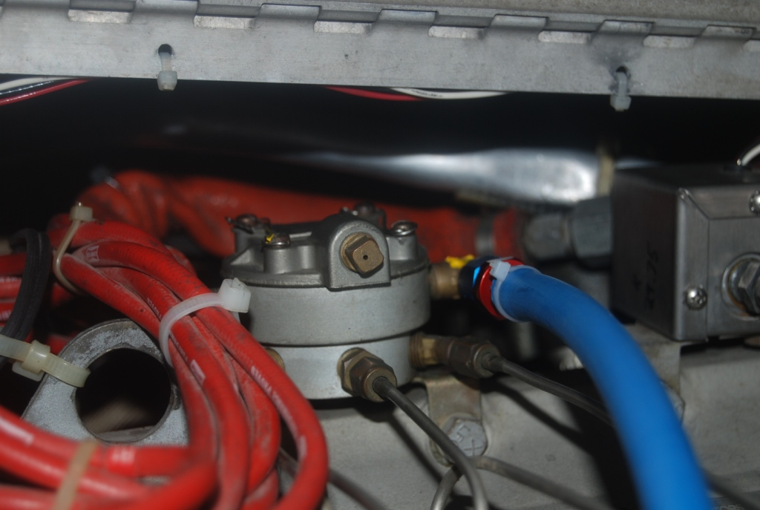

Photo 6: Fuel Distributor (spider) with blue pressure gauge hose connected directly to an installed AN-4 compression fitting. Your plane may not have this, in which case you will use a Swivel Tee fitting in the fuel line from the fuel controller to the fuel distributor.

- Following the SID instructions, run up to full power, full rich. Verify the rpm using the digital tach.

- If the engine will not spin up to the specified rpm:

  - Some planes will not achieve full rpm when sitting on the ground, but will reach it when accelerating down the runway or flying. In this case, perform the static run-up test and adjust the numbers using the correction factors in the SID.
  - However, if at full power your engine is unable to get full rpm in flight, the governor stop screw probably needs adjusting. However, other problems are possible which are beyond the scope of this article.

- If the engine exceeds the specified rpm during a full power static run-up do not attempt to read the gauges or change injector settings. Also, do not attempt to compensate by retarding the throttle. The prop governor may need to be adjusted. However, there could be other problems beyond the scope of this discussion.

- As mentioned earlier, if you have an accurate fuel flow computer, use it to set the full power metered fuel flow to the high end of the SID specification. Record the reading from the Wika pressure gauge and verify it is in the range specified in the SID. If the fuel flow is correct, but the pressure is not, you have a fuel system problem that must be identified and corrected. Do not fly the plane in this condition.

- If you do not have a fuel flow computer, set the full power metered fuel pressure to the high end of the SID pressure specification.

- Once complete, recheck the idle unmetered pressure, idle speed, and idle mixture. If any changes are required, recheck the full power fuel flow/metered pressure. Continue in this loop until all readings are correct.

Caution: Some TCM engines have fuel dividers equipped with two identical looking elbow fittings. However, they may not be identical! A standard AN-4 elbow fitting should connect to the fuel line from the fuel controller. In some cases, the other elbow is a restrictor fitting with a much smaller passage. It is intended to feed an airframe fuel pressure gauge (or if capped and unused, can feed your Wika gauge!). It is possible for these fittings to get accidentally reversed during servicing or when installing new equipment (like a fuel flow computer sensor). If this happens the fuel injection will not calibrate properly. The engine will run too lean and can be damaged. The two elbows look identical from the outside, and must be removed and compared carefully to see the difference. If a restrictor fitting is present on your airplane I recommend that you apply red or yellow paint to highlight this difference for the future, see photo 6 above.

Conclusion

Hopefully these notes will be a helpful supplement to TCM SID 97-3E and allow you and your mechanic to calibrate your fuel injection precisely and quickly. In the case of my airplane, it made a world of difference in both engine performance and cylinder head temperature.

Finally, these notes are observations from a non-mechanic owner. Always use a qualified mechanic and follow TCM and airframe manufacturer documentation. Use any of the information or recommendations contained here at your own risk.

