Notes on TCM SID 97-3E
Turbocharged Engine Supplement
Dan M.
September 2010
Version 1

This document is a supplement to the previous “Notes on TCM SID 97-3E”, so that information will not be repeated here. Instead, I will attempt to clarify some confusing elements of the SID, adding information that may be of help to an owner.

Note: Enlist the help of a properly certified mechanic and be sure to follow TCM and airframe manufacturer manuals and publications before performing any fuel injection work. Use the following information, or not, at your own risk.

Tools

First, the SID specifies the tools required to adjust your fuel injection. It recommends the Model 20 ATM-C Porta Test Unit, which unfortunately costs thousands of dollars. However, it also lists alternate tools, including a “differential pressure gauge” for turbocharged engines. This gauge is really two instruments-in-one… one bourdon tube forces the gauge pointer up, the other forces the gauge pointer down. The net effect of this tug-of-war inside the gauge is the difference in pressure between the two pressure sources. These gauges are very expensive ($800+), yet generally have half the precision of a standard gauge.

A little explaining is needed…

- The turbo pressurizes the intake system at higher power settings. The tube carrying the pressurized air from the turbo to the throttle plate (butterfly) is called the “upper deck”, and the air pressure inside is called “upper deck pressure”.

- The pressure of the air downstream of the throttle plate is called “manifold pressure”, and is shown on the familiar manifold pressure (MP) gauge on the instrument panel. It is lower than the upper deck pressure due to the air passing over the throttle butterfly.

- Each fuel injector is fed air from the upper deck, rather than ambient air as in a normally aspirated engine, so that the fuel is properly atomized. If the engine designers had used conventional injectors the fuel and compressed air would squirt back out the injector bleed holes.

- The fuel must be supplied to the injectors at a pressure exceeding the pressurized bleed air, or no fuel will flow.

- The key to the fuel flow rate is the difference between the fuel pressure and the upper deck air pressure. The differential pressure gauge is used to measure this.

Since the Porta Test Unit costs thousands of dollars, and a differential pressure gauge costs $800+, then turbo owners are stuck spending big bucks for proper tools… or are they?

As far as I know the following alternative approach has never been published before. Perhaps I was the first to try it? In any case, read through the descriptions, work through the logic and math, and give it a try if you are so inclined. “Your mileage may vary”!

A differential pressure gauge really just measures two pressures and displays the difference, with some reduction in accuracy in the process. What if we measure each pressure separately, and subtract the lower pressure from the higher pressure to get the difference? One potential problem is the cumulative error of two gauges… but wait, the differential gauges have the same problem since they really are two gauges internally, and the resulting lack of accuracy is published in their specifications. With good standard gauges, careful reading of the pressure values, and proper arithmetic, we can get usable results.

So what range of pressures need to be read? We will be measuring:

- Upper Deck Pressure: This will be slightly higher than the maximum manifold pressure allowed for the engine. A standard gauge is referenced to ambient air pressure, and measures in psi. Approximate the full throttle pressure reading that will be displayed on the gauge by subtracting ambient from the manifold pressure and convert inches of Hg to psi. For example, for an engine with a maximum manifold pressure of M inches Hg and an ambient air pressure of A inches Hg, the gauge will display about G psi:

(M – A) * 1 atmosphere/29.92” * 14.7 psi/1 atmosphere = G psi

If we were performing this test in Colorado, on some models of TSIO-360 engines, the numbers will be around: (36” – 25”) / 14.7 = 5.4 psi. The 0-15 psi Wika gauge mentioned in my first article will work well for this.

- Metered Fuel Pressure: This will be approximately the full power pressure listed in the SID, plus the upper deck pressure. For example with certain versions of the TSIO-360 this will be about 15.3 psi + 5.4 psi = 20.7 psi. The 0-30 psi Wika gauge mentioned in the first article will be excellent for this purpose.

Note that if the above examples were actually measured, we would have an indicated fuel pressure of 20.7 psi, minus a measured upper deck pressure of 5.4 psi. The differential pressure would be 15.3 psi… which is right back to what we want. Bingo, differential pressure measurements using conventional gauges!

Photo 1 below shows actual measurements taken on a TSIO-360 engine at an airport elevation of 5,500’.

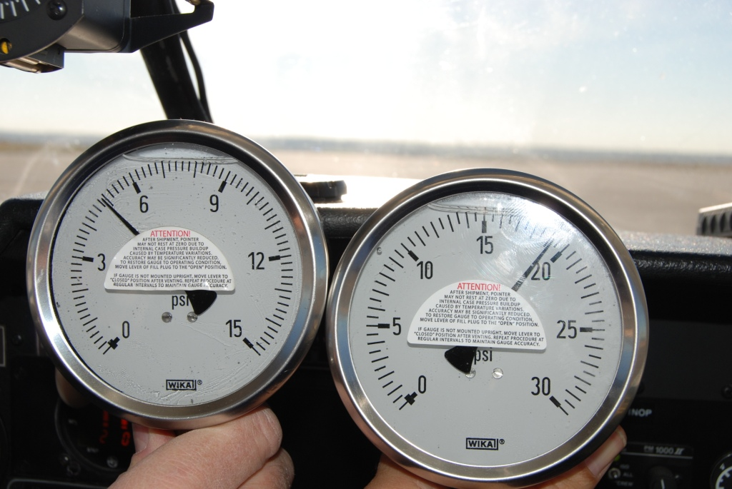

Photo 1: Standard pressure gauges -
upper deck pressure of 4.9 PSI on left,
metered fuel pressure of 19.2 PSI on right

The SID specifies a standard pressure gauge to measure the idle unmetered fuel pressure. This does not involve differential pressure measurements. For most engines this will be in the 5.5 – 9 psi range, so the 0-15 PSI Wika gauge shown in Photo 1 can also be used for this purpose.

The use of an electronic tachometer and fuel computer also apply here. We recently tested a TSIO engine and discovered the aircraft tach was showing 50 rpm below red line on a full power takeoff, while an accurate electronic/optical tach showed that engine was actually 60 rpm above red line! A properly adjusted governor is essential to completing the fuel injection setup.

Procedure

Follow the SID instructions carefully. Note the following additional hints (in addition to those noted in the first article):

- Figure 12 in the SID shows a fuel line running from the fuel pump to an unmetered fuel pressure gauge, and another fuel line running from that gauge to the fuel controller. It does not show a tee connector, like in all the other diagrams. It should! That gauge is not a differential gauge.

- Figure 12 shows a fuel pressure regulator. This may or may not be present on your airplane. If present, you must handle it per the SID.

Idle Unmetered Fuel Pressure, Idle Mixture, and Idle Speed

- Connect the 0-15 psi gauge between the fuel pump outlet and the fuel controller. Some engines may have a capped fitting pre-installed near the fuel controller for this purpose.

- Set the idle unmetered fuel pressure, idle mixture, and idle speed per the SID.

Full Power Metered Fuel Flow

- Connect the 0-15 psi gauge to the upper deck reference point. The SID shows this connecting to a differential pressure gauge. There may be a capped fitting pre-installed in the upper deck area for this purpose.

- Connect the 0-30 psi gauge to the metered fuel pressure reference point. The SID shows this connecting to a differential pressure gauge. There may be a capped fitting on the fuel divider (spider) for this purpose. You can use a tee fitting in the fuel line instead.

- If you have an accurate fuel computer, run the engine at the specified high power RPM and adjust the metered pressure to achieve the upper end of the fuel flow range per the SID. Retest, and make further adjustments. Also, measure the pressures at the specified full power RPM. Subtract to obtain the differential pressure. Verify that the differential pressure is in the range specified by the SID. (If the fuel flow is correct but the pressure is not, you must find and fix the cause before further flight.) Retest the idle pressure/mixture/speed per the SID. Repeat until no further changes are needed.

- If you do not have a fuel computer, run the engine at the specified high power RPM and measure the pressures. Subtract to obtain the differential pressure. Adjust the metered pressure to achieve the upper end of the fuel pressure range per the SID. Retest the idle pressure/mixture/speed per the SID. Repeat until no further changes are needed.

- Many engine experts recommend setting the full power fuel flow 1-2 gph higher than TCM specifies. Of course, this will also result in a higher full power metered fuel pressure reading. This can help lower CHT’s during takeoff and climb. On a recent test with a TSIO-360 we found that a change from 22 gph to 24 gph decreased the highest CHT from 420 F to 380 F, at the expense of some fuel burn and slightly reduced power output by running rich. Your results may vary.

Conclusion

Hopefully this information will be a helpful supplement to TCM SID 97-3E and allow you and your mechanic to calibrate your turbocharged fuel injection precisely and quickly.

Finally, these notes are observations from a non-mechanic owner. Always use a qualified mechanic and follow TCM and airframe manufacturer documentation. Use any of the information or recommendations contained here at your own risk

